Two Contributions to Foster Human Agent Interaction, the MCS Theory of Cognition and the Piaget Integrative Environment

Jean-Daniel Dessimoz and Pierre-François Gauthey

HES-SO Western Switzerland University of Applied Sciences

HEIG-VD School of Business and Engineering

CH-1400 Yverdon-les-Bains, Switzerland

Jean-Daniel.Dessimoz@HEIG-VD.ch

Abstract: Humans have started to develop smart devices and techniques, but two critical challenges appear. One is to rigorously define and quantitatively estimate cognition processes and entities; the other one to coordinate heterogeneous resources. Cognition is the capability to generate pertinent output information, depending on circumstances. Additional definitions are proposed in cognitive and machine contexts, for key notions, in particular « agent, interaction, and mediation». An overview of MCS theory for cognitive sciences is briefly presented. Cognition must be grounded in the real-world ; therefore we have created Piaget, an environment for development, programming, and real-time control of complex robotized systems, presented here in terms of strategic requirements, and main capabilities. Finally, three examples illustrate how, with Piaget, to estimate cognitive quantities, to support multimodal human-agent interaction, as well as to manage interactions betweeen human and robots, with mediation by a humanoid.

1 Introduction
Through millenia, humans have progressively developed tools, techniques and methods of increasing sophistication. Until recently, more sophistication in tools meant more requirements on the human side.
With the occurrence of smart systems, especially in electronics and computer technologies, the trend has moved in two opposite directions: on one hand device complexity has exploded; and on the other hand progress in interaction techniques have lead to many examples where tasks require, from human users, skills compatible again with more natural and intuitive kinds of expertise.
Successes seem numerous and progressing [e.g. 1, 2], yet failures are also common, sometimes with dramatic intensity. Two particularly significant cases are considered here. 1. Even though AI appears to have brought some very significant results, for nearly every people, AI can ultimately only remain an empty domain, because for their intimate beliefs, i.e. their implicit definitions, intelligence is exclusively human and thus cannot be machine-based. For an early description of this phenomenon, see [e.g. 3]. 2. Many smart sensors, computing devices, as well as excellent actuators are available [e.g. 4]. Their integration though, when available, is mostly achieved as very specific solutions, leading to complete, “closed” applications for the users, and they are typically delivered as turnkey or “one button” solutions by the manufacturer (e.g. GPS, smart phones, robots for aided-surgery, humanoids).
Thus two factors are now critical for progress. What is lacking on one hand is a corpus of definitions, measuring units, techniques and methodologies applicable in the new field which opens beyond elementary information processing, (automated) cognition, including (artificial) intelligence; in this regard, many of the agents we refer to in this conference are in particular cognitive agents.
On the other hand, agents typically need to ground their observations, operate their cognitive processes and deploy their decisions, all in the real-world (re. also “embodiment”). A critical factor is then the availability of a powerful integrating framework, capable to foster the various phases - development, programming , and real-time supervision – of novel projects for complex real-world systems, featuring multiple heterogeneous resources made available by published research works or provided by the market, as commercial products, services, subsytems. Attempts to address this challenge include [5-8], and some other ones discussed in [9] .
In this regard, the current iHAI Conference is timely, explicitly addressing essential related themes (theoretical modeling, artificial agents, embodiment, interaction and learning) and expanding the move already wisely triggered [10]. Our paper will contribute to these themes in two respects reflecting the two critical factors introduced above: 1. providing and extending a universal theoretical model for cognition, MCS [11, 12] ; 2. reporting, with a human-agent-interaction perspective, on the Piaget architecture and environment, capable for machine-based agents to effectively implement cognitive processes and connect them to the real-world, integrating for a selected purpose the most appropriate, available, mostly heterogeneous subsystems [e.g. 9].
Our goal is primarily to design smart machines capable to change the world, for the benefit of humans.
The paper is organized as follows. Section 2 discusses and formally defines the concepts of agent and interaction, in coherence with the MCS, and refering also to the notions of communication and mediation. The next two sections, 3 and 4, develop the main two contributions, first relative to cognitive agents, and MCS, and second discussing forces and power, and Piaget.
2 Agent, Interaction and Mediation
The paper title includes several words not defined in MCS ontology yet [11 for a synthesis]. We address here the first two of them, agent and interaction, as well as a third notion of high interest, mediation.
2.1 Definition of “agent”.
The definition of agent is first discussed for the context of humans, then for machines.
2.1.1 Definition of “agent” in human context
The Merriam-Webster (MW) dictionary [13] is a good reference for the meaning of words in human context. At the article “agent”, 5 different definitions are provided. The first one refers to a human doer, with action and power, in complete coherence with the meaning of its etymological root.
The second meaning focuses on elementary components (e.g. chemically active liquid) having operational effects of material nature. The third meaning extends the notion to more complex means.
The fourth definition refers to the notion of human representative, thereby shifting the role of agent to “acting” versus stragetic decision-making.
On the contrary, the fifth meaning, for computer-based applications, is restricted to the cognitive stage.
2.1.2 Definition of “agent” in machine context
It will help to provide first a schematic definition of robots and of cognitive systems. Fig.1 presents a model for robots, which includes, in addition to the generalized cybernetic loop (control-decision, action on environment, and feedback-perception), the locomotion and communication capabilities.
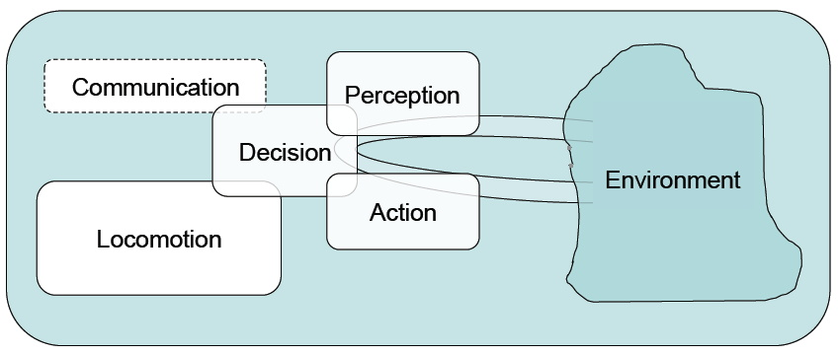
- Schematic view of a robot, modeled as featuring 5 essential capabilities.
Consider in particular the decision block, where cognition mostly operates. Primarily knowledge-driven, the decision block, 1. receives some input information from perception block, 2. processes it and cranks up the corresponding output information, and finally, 3., transmits it to the action block. Similar information exchanges also commonly occur with two ancillary functions, locomotion and communication.

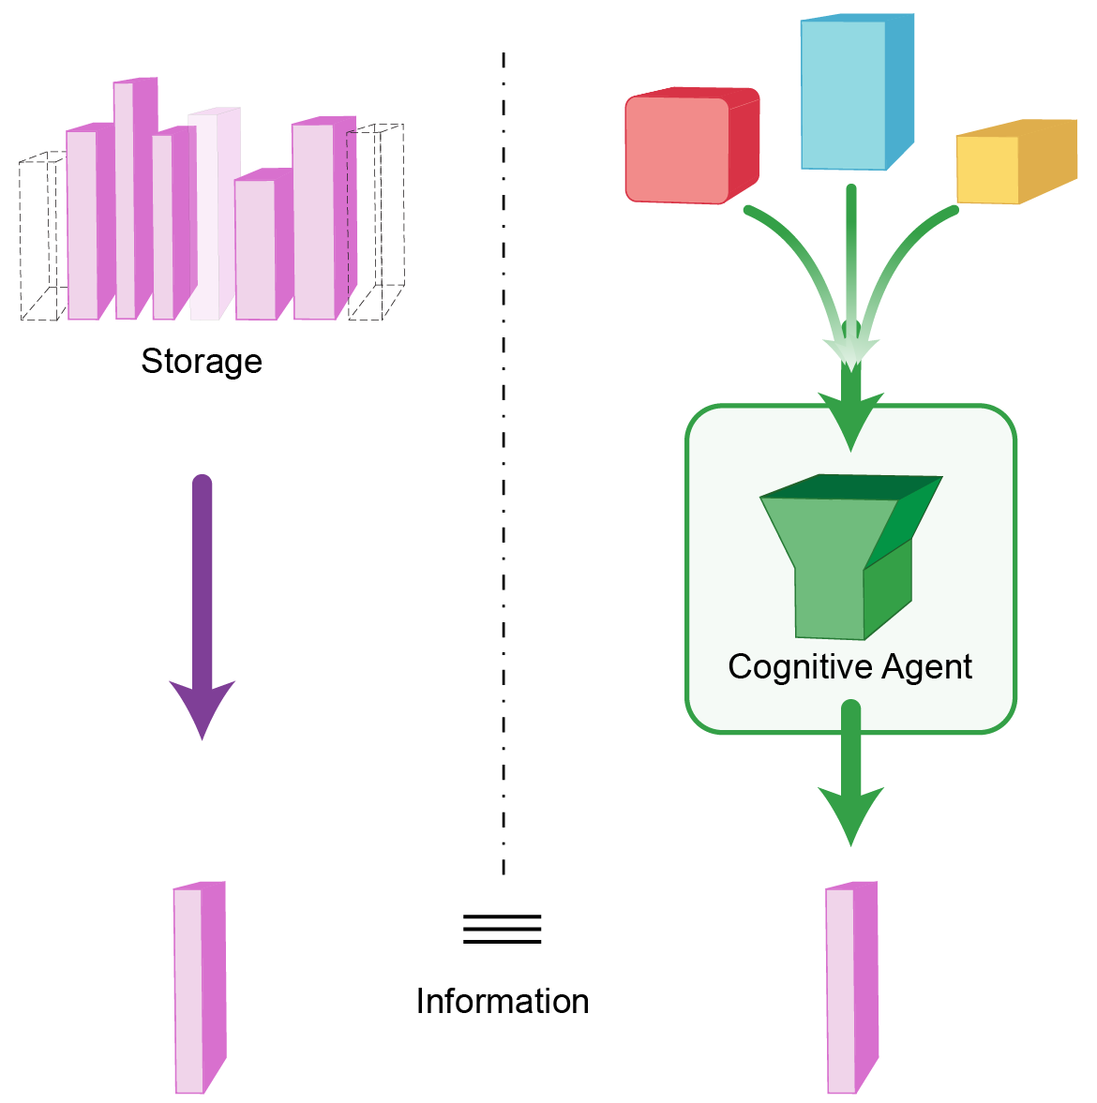 | 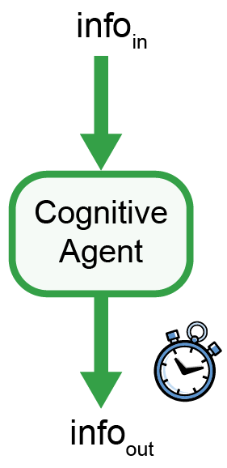
a | b
- Schematic view of cognition. a: Cognition and, effectively, cognitive systems (re. text). b: Cognitive properties can be quantatitatively estimated on the basis of the input-output information flows, and time (re. text).
Cognition and, effectively, cognitive systems, allow for generating relevant information, exactly similar to pre-stored information - when the latter is available (Fig. 2a). Cognitive properties can be primarily defined and quantatitatively estimated on the basis of input- output information flows, and on the additional basis of operational time (re. Fig. 2b). Some kind of cognitive engine is necessary (human- based, or artificial, i.e. implemented on machines) .
On the basis of above models, the notion of “agent” can be defined in four different variations.
Agent definition 1 - universal. The first definition for “agent” refers to the loose idea of a “doer”. In this “universal” way, the global robot of Fig.1, and all of its 5 functional blocks, as well as the cognitive systems of Fig.2, can all be viewed as some kinds of agents.
Agent definition 2 – cognitive. Here it is important to recognize a huge difference between the world of cognition as implied by the cognitive agent of Fig.2b, and the real world. In the former case, cognition exclusively relates to information, which is immaterial. As such, cognition inherits of information properties and in particular of its immaterial nature. This also applies to the case of definition 5 in above dictionary (re. §2.1.1) and generally to all computers, as well as digital networks. In particular, this definition usually applies very well to the decision block of Fig.1. It could also often be fruitfully adopted for the communication block.
Agent definition 3 – embedded in the real-world; embodied. Generally, an agent is expected to perform in the real-world. As in definition 1 of above dictionary (re. §2.1.1), there is an associated notion of power.
In practical terms, even operating on immaterial representations, cognition requires, as illustrated in Fig.2a, a physical “engine” to crank out relevant information, and must therefore necessarily be implemented in the real-world; typically the cognitive engine consists in a brain, neurones, a computer, electronic circuits or digital networks.
Similarly, in the real world, for communication purpose, information is not enough; we need signals, i.e. also a physical support (electrical voltage, light, etc.).
To yield most of its potential benefits, cognition must be connected to the real world. Thus most of the functional agents of Fig.1 (perception, action, locomotion) are required; they essentially mediate between the real world and the cognitive world. Those functions can be distributed in many ways in mechatronic systems, but robots provide in principle a compact, minimal configuration of high interest, which very evidently corresponds to biological systems – insects, animals, and to some extent, humans.
Agent definition 4 – active in the strict sense. In the robot model of Fig. 1, the action block is the one that most evidently matches the strict definition of an agent. Both words, action and agent, share the same origin. Here some physical cause is harnessed in order to change the state of the real world. Typically, this is where power, measured in “watt”, plays a necessary role.
In the strict sense of agency, the locomotion block is similar; it could well be viewed as a particular kind of action; yet due to the importance of mobility, i.e. capability to change of space location, in our classical culture (re. space-time dimensions), locomotion is granted its own specificity. And ultimately, as mentionned abouve, all the functional blocks of our robot model require some power in practice.
Notice that the present strict definition of agency overlaps very well with the 4th definition in Webster-Merriam (re. §2.1.1), which, in particular, focuses on action capability, and, explicitly leaves strategic decision-making to other bodies.
2.2 Definition of “interaction”
The definition of interaction is discussed here like above, first for the context of humans, then for machines.
2.2.1 Definition of “interaction” in human context
The Merriam-Webster dictionary primarily describes interaction as follows: mutual or reciprocal action or influence. It provides an additional view of the involved agents: people, groups, or things.
2.2.2 Definition of “interaction” in machine context
The above dictionary definition of interaction is in principle applicable to machines as well. In fact the Merriam-Webster already mentions “things” as capable of interaction, which includes machines. It is worth though to clarify here the definition for machine context.
On one hand, we can rely in particular on the 4 definitions of agent, re §2.1.2, for clarifying, in the same way, the meaning of the word action.
On the other hand, the new term to discuss is here “influence”. In technical terms, it can be modeled as the kind of action that does not (primarily) require power: transmission of information, communication.
Interaction definition 1 – universal. The MW definition for “interaction” can be taken in a general way (re. action or influence nature). In this “universal” way, the global robot of Fig.1, and all of its 5 functional blocks, as well as the cognitive systems of Fig.2, all can be viewed as capable of some kinds of interaction.
Interaction definition 2 – cognitive. In the same way as cognitive agents deal exclusively with information, including when appropriate immaterial models (e.g. representations, codes) of physical entities (e.g. forces and power), cognitive interaction exclusively implies communication (re. also “influence” in MW definition).
What is new here is the implied notion of multiplicity of interacting agents. In cognitive terms and for the more complex cases, the notions of common culture, including in particular language arise.
Interaction definition 3 – physical. In a complementary way to cognitive interaction, physical interaction requires deployment in the real-world. Robots (physical ones!) in particular typically provide the appropriate means for that. And other distributed resources may also be effective.
2.3 Definition of “mediation”
Mediation is defined here with the same structure as above, first for the context of humans, then for machines.
2.3.1 “Mediation” in human context
The MW dictionary primarily describes mediation in two steps: in step 1, mediation is the act or process of mediating. Then, in step 2, “to mediate” is also defined, essentially with different six modalities.
While interaction was defined above typically between two agents, mediation implies a third agent in between (“intermediary”), somehow facilitating interaction, “exhibiting indirect causation, connection, or relation”.
In human context, there is most often a connnotation of conflicts to be resolved between the initial two interacting agents. It is also stated though that mediation can “reconcile differences”.
2.3.2 “Mediation” in machine context
In machine context, mediation is similarly ensured by a third agent, between 2 main agents, and its role is to facilitate interaction. Here it is the latter quote from MW dictionary that typically applies: “reconcile differences”.
Differences are best understood in cognitive terms, even though in the real-world, other aspects, of physical nature, cannot be totally ignored.
In our research, we have found that a humanoid (NAO of Aldebaran Robotics in our case) could prove an excellent mediator between humans and other robots and machines (e.g. our RH-Y and OP-Y robots). On the human side, the humanoid shape, “beautiful, attractive” look, and the commonly known location of input channels (ears, “eyes”, microphones, cameras) as well as humanoid behavior (e.g. head following visual points of interest, such as human faces) help human partners interact with it; on the machine side, usual wifi communication and protocols can readily ensure effective communication between the humanoid and other technical artefacts. Thus the humanoid can “reconcile differences” between the two types of culture – human and machine-oriented.
3 Cognitive agents – and MCS
Cognition is a scientific and technical domain where, mostly, formal foundations are still lacking or are unsufficiently widespread (re. below). In particular hardly any cognitive entities (e.g. complexity, knowledge, expertise, learning, intelligence) can commmonly be quantified with standard units. This is in sharp contrast with physical entities, such as time, length, weight or voltage for example.
The key element in cognitive domain, that has been given a proper theoretical basis, and a measuring unit (“bit”), is the one of information. It does have some aspects difficult to get accustomed to, in particular its subjectivity, time-dependance, and limited scope, constrained by underlying models. Nevertheless this basis is sound. Time is relevant too in cognition [e.g. 14]. These two notions are fundamental for MCS theory.
MCS formal definitions and metric units for cognition are documented elsewhere [e.g. 11, 12]. Here, as a new complement, Table 1 provides just a short, intuitive description of the same key cognitive concepts.
Entity  Model  Information  Complexity  Knowledge  Expertise  Learning  Experience  Intelligence | Brief description  Goal oriented, elementary representation  Builds-up receiver’s opinion  Amount of information required for description  Capability to crank out the right information  Capability to crank fast the right information  Increasing the quantity of expertise  Amount of information witnessed  Ratio of learning versus experience
Table 1 Brief intuitive description of cognitive concepts formally defined elsewhere in MCS, along with specific measuring equations and units.
Notice that the model of cognitive agent presented in Fig. 2 equally applies to systems implemented in diverse substrates (e.g. computers, robots, or human brain).
Similarly, it applies at all scales, i.e. as well to the agent her/him/itself as to possible subsystems (e.g. for brain regions – re thinking), or meta levels (e.g. for a group – re deliberations among interacting agents).
This latter point deserves a special attention in the context of iHAI Conference, and is illustated in Fig. 3 .
When considering a metastructure integrating multiple individual elements, a group, we recognize a common case of human organisation, for which various kinds of developments have been made through ages, in particular as studied in sociology [12]. Here, individual agents may be very heterogeneous, including e.g. humans, robots and computers.
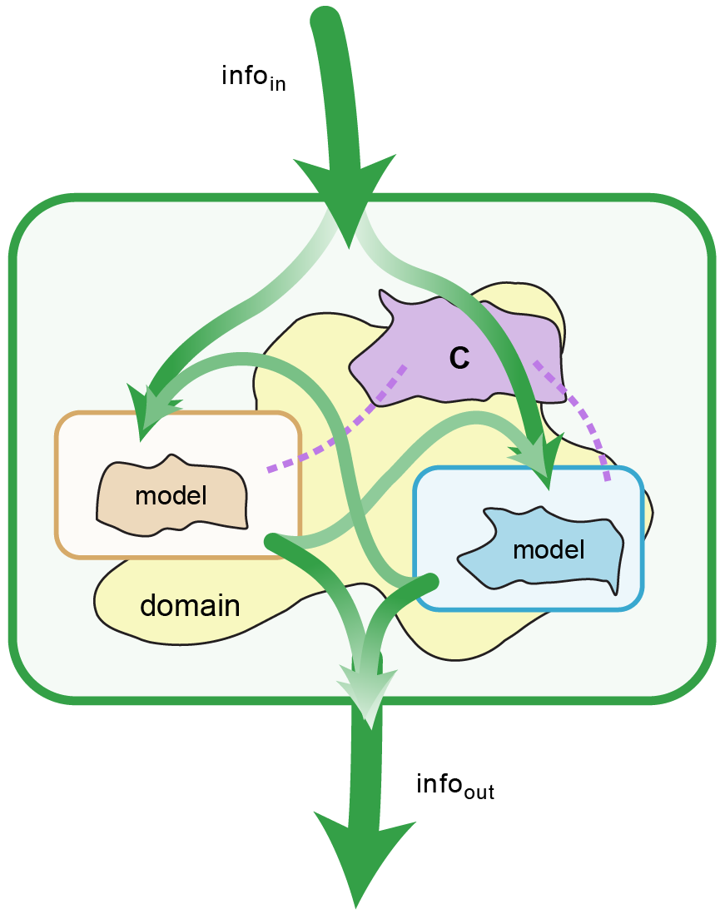
- At an individual scale, single agents update their own models as information is received. Together, as they share common model elements, C (like culture), they implicitly build-up a group, which globally can also be viewed as a new, single agent.
4 Forces and power – and Piaget
Cognition alone cannot change the world. This section discusses in four successive points how an action can be enforced in the real-world, how in this attempt Piaget had to be invented, what are some of the main strategic requirements under consideration and finally some of the key capabilities that have been built-up in Piaget [15].
4.1 Action in the real-world
As already stated above, to have an effect in the real-world, an agent must have power (re. in particular agent definitions 1, 3, and 4, in §2.1.2.).
At the core of the smart agents currently being typically considered, we have cognitive agents. They operate within models, i.e. in cognitive worlds. Let’s assume, as is already often the case today, that the latter do provide the relevant decisions (correct output information) in the domain they were designed for. Yet how to to deploy those decisions in the real-world?
It was already stated in §2.1.1 that there is a huge difference between these two worlds, cognitive and real. Well, how huge? Let’s get quantitative: the complexity of current cognitive models may amount to a few kilobits, megabytes, or possibly, if we succeed in harnessing the internet, even much larger quantities. Yet in relative terms, this keeps amounting to nil, for reality is not only a model; the complexity of reality is infinite, no matter how the domain under focus is constrained.
Notwithstanding the cognitive challenge, experience shows that humans have already developed many successful means of transition between both worlds, and keep doing so, especially in technical terms currently. Important categories include for us managing memories (re. e.g. tying a knot in one’s handkerchief, painting, writing and reading, using solid-state circuits, etc.), perception and sensors (capacitive switches, microphones, cameras, encoders, etc.), action markers and “actuators” (LED’s, horn, relays, motors, loudspeakers, graphic displays, industrial manipulators, etc.), communication devices (receivers, transmitters, wi-fi nodes, hubs, etc.) and mediators (e.g. humanoid).
Robots integrating both, cognitive abilities and physical devices, as schematically represented in Fig.1, are very interesting systems. Notably they can change the real-world. They can be autonomous, and cooperating with humans. As their capabilities grow, this becomes always more true.
4.2 Piaget, out of necessity
Research publications, the market, and other sources yet offer a lot of effective components. They are extraordinarily heterogeneous, each matching at best their specific domain of operation. Our experience has been however that a versatile framework was missing for coherently integrating an appropriate selection of these components into a single, coherent, synergestical system, for a given purpose, such as a Eurobot competition, a Robocup@Home test, or some industrial assembly tasks.
This is why we have created Piaget. The requirements we have set for our developments have evolved through the years, depending on circumstances, especially for more detailed technical aspects.
4.3 Some strategic requirements for Piaget
Strategic aspects remain more permanent and some of the requirements adopted for Piaget are the following:
- Ultimately, comply with goal requirements (get the job done, follow the rulebook, etc.)
- Use the best current resources and practices
- Focus on critical factors
- Iteratively test and improve incrementally
- Test the system as globally as possible, which implies the next point:
- Simulate as necessary missing components.
4.4 Some technical capabilities of Piaget
With the strategic requirements in mind, we have worked out numerous Piaget capabilities, and a selection of them follows, in current state:
- Kernel for parallel process management: the Piaget scheduler switches processes every 100 nanoseconds in average; the minimal programmable sleeping time for a process is on the order of 1 microsecond.
- The Piaget environment can be “programmed” in four levels of increasing scope and expertise requirements, as follows:
- Level 0 is interactive, allows for permanent system configuration changes, and features many immediately interpreted controls.
- Level 1 is very user-friendly, with many application-oriented, semantically rich Piaget instructions.
- Level 2 is somewhat more demanding in terms of user com- petences for Piaget, and allows for new parallel processes.
- Level 3 is restricted for experts, and allows to implement and optimize the Piaget environment on different digital platforms, with different implementation languages.
- Dynamic constraints are taken into account, based on the agility of each control process, relative to the (sub-)system under control. This in particular guides the choice of architecture and resources, as well as limit-setting in terms of autonomy.
- Currently, integrated resources in Piaget framework include the following: C++ compiler, Windows OS, laptops, TCP/IP connections, Vocal API, Axis color and thermal cameras, Mesa-imaging TOF camera, Kinect sensor, Beckhof PLC, Baumer inductive and ultrasonic sensors, USB connections, Hokuyo rangers, Fiveco and Galil servocontrollers, Katana arm and gripper, Kuka and Stäubli industrial arms and controllers, NAO humanoid. Notice that the integrated resources in turn may have their own conventions and tools (e.g. languages and OS: C# , Python, Choregraph, Linux, KRL, Val-3, IEC 61’161, etc.). Moreover the TCP/IP and USB ports open a virtually endless list of networked resources, incl. e.g. Webots. Notice also that Piaget environment is an essential part of our numerous proprietary robots: Diego³, Arthur, Alf, RH-Y, OP-Y, etc.
- Piaget language instructions provide high-level instructions for level 1 users, solving internally important algorithmic and computational issues, critical for percep- tion (incl. for vision, ranging, supervisory I/O manage- ment), locomotion and handling (e.g. frame calculus, kinematics, motion laws), communication (e.g. vocal dialogue management, real-time NAO behavioral and joint management), and when ever useful, application- oriented primitives (for ex. “ChooseBridgeVisually”).
- Piaget features both a general-purpose, cockpit-like interface where 100 actions or more are possible in zero or one click; it also features specialized, application- oriented forms (e.g. for parametrization, test and development of vision processes, localization on a map, industrial arm control, cognitive assessment, etc.) to be opened interactively and/or by program.
- Our Piaget environment is developed collaboratively and much of the software aspects are managed in “subversion” context; solutions have been capitalized in several ways, essentially for 15 years, and applications are, in fine details, present in the latest version, for about the last 5 years, which is identical for all platforms.
- The applications we have addressed always require a specific subset of the resources integrated in Piaget framework. A possible shortcoming though, currently, is that all potential drivers required by Piaget for execution in the real-world need be installed.
5 Examples of cognitive assessment and of Piaget-driven tasks
This section successively provides three examples. The first one relates to MCS metrics, the second one to an ongoing project being developed in Piaget environment, and the third one presents an interesting case where interactions occurred between a human and a robot group, featuring a humanoid among other robots.
5.1 Going quantitative in the cognitive world
The MCS Model provides metrics for assessing cognitive entities in terms of definitions and equations; Piaget offers in particular a didactic example as well as a form computing these cognitic equations.
Fig. 4 displays the a didactic case in Piaget: the user clicks on 5 targets, as exactly as possible in the center. Depending on user’s expertise, the accuracy may be good, and the time to perform the task, short.
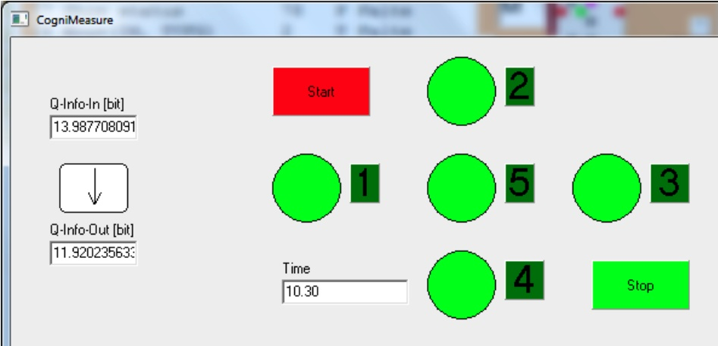
- Piaget includes a didactic example: the user clicks in the center of the 5 targets (see text).
The system computes on its own the quantity of incoming information, outgoing information, from the player (cognitive agent), as well as the response time .
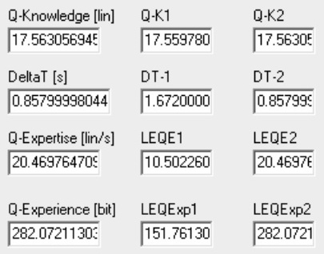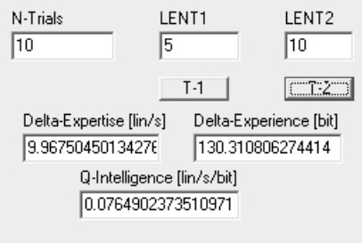
- Automatic computation of key cognitive quantities.
Fig 5 displays the corresponding cognitive quantitites in terms of knowledge, expertise, and experience. These first results may be stored in memory (case T-1). Then if the task is repeated, new values are measured. When stored as T-2 case, the differential values of expertise and experience can be computed and allow for the estimation of intelligence quantity (in lin per second per bit). By definition, if the differential expertise is positive, some learning occurs; the value is actually the learned quantity.
It is also possible for users to feed selected values (e.g. expertise in case T-2) and thereby have the application estimate the resulting values in this new case.
5.2 TeleGrab
Consider our recent “TeleGrab” application, which primarily involves Piaget, our RH-Y robot, and interesting cognitive capabilities in a context essentially involving human-agent-interaction (Fig. 6).
In short, the application consists in having a human with low mobility (e.g. in a living-room), who remotely interacts with RH-Y robot, having the latter fetch an object (e.g. in the kitchen) and bring it to him/her.
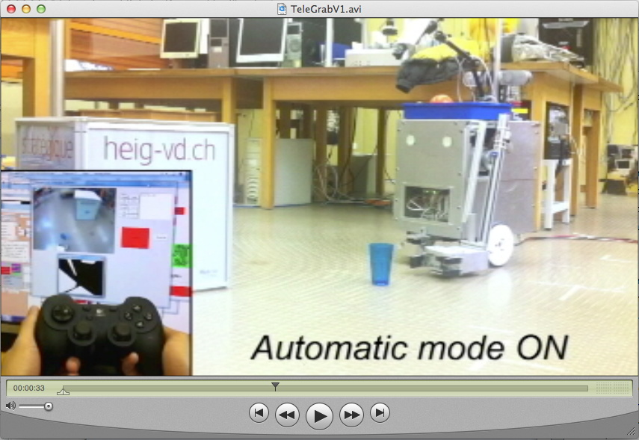
- A composed view of our TeleGrab application (see text).
Schematically, three classes of operations are available in this concept: 1. Low-level, manual control for navigation, as well as arm and gripper control; 2. Adaptive mode, possible when robot-object distance is in the last 90 cm: if the user chooses so, the robot “docks” and grabs the object on its own; 3. Autonomous robot navigation to selected locations at home.
5.3 RG-Y in Singapore
In Singapore, for Robocup@Home competition in 2010, an interesting application, managed in Piaget context, has been demonstrated, where various interactions could successfully happen between a human, and a robot group, RG-Y, consisting in a humanoid and 2 other robots (re. Fig.7).
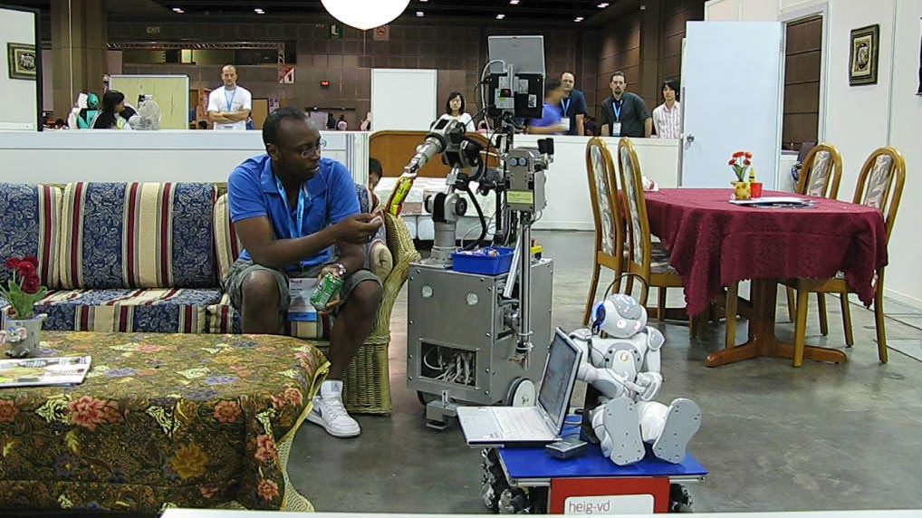
- Human agent interaction involving a human, a humanoid and two other robots.
Nono-Y, our reconfigured Aldebaran NAO humanoid, was riding our omnidirectional platform OP-Y for reasons of secure displacement. Its assigned role was to mediate between human and machines. So the humanoid came to the living where Daniel was sitting, and asked him whether he was thursty. He was. Nono-Y then went to the kitchen to fetch its mate RH-Y, that came to the living, bringing in one “hand” a can of beer, and with hits other arm, served snacks to Daniel, from its blue tray (which, when necessary, can be cleaned in dishwasher).
Very significant cognitic performance levels could be achieved (Knowledge: ca 1MLin, Expertise: ca 100kLin/s).
6 Conclusion
Humans start to develop smart devices and techniques, but two critical challenges now appear. One is to rigorously define and quantitatively estimate cognition processes and entities ; the other one, to coordinate heterogeneous resources. Cognition is the capability to generate pertinent output information, depending on circumstances. Additional definitions are proposed in cognitive and machine contexts, for key notions, in particular « agent, interaction, mediation». An overview of MCS theory for cognitive sciences is briefly presented. And cognition must be grounded in the real-world ; therefore we have created Piaget, an environment for development, programming, and real-time control of complex robotized systems. It is presented here in terms of strategic requirements, and main capabilities. Finally, three examples illustrate how, with Piaget, to estimate cognitive quantities, to support multimodal human-agent interaction, as well as to manage interactions betweeen human and robots mediated by a humanoid.
Acknowledgement
The authors gratefully acknowledge numerous contributions of research funds, industrial partners, students, interns and technical departments at HEIG-VD.
References
- Kurzweil , Ray, How to Create a Mind : The Secret of Human Thought Revealed, Viking, , 336 p., (2013)
- Hofstadter, D. R.: Trying to Muse Rationally about the Singularity Scenario, Singularity Summit, Stanford, May, http://www.youtube.com/watch?v=Nhj6fDDnckE (2006)
- Feigenbaum, Edward A.: Artificial intelligence: themes in the second decade. IFIP Congress (2), (1968)
- Dorrier, J., http://singularityhub.com/2013/04/28/robots- will-do-everything-you-do-now-only-better-what-then/ , Posted: 04/28/13, last accesssed 7 May (2013).
- Microsoft Robotics Studio 4, last accessed http://www.microsoft.com/robotics/, 7 May (2013)
- Quigley, M., Gerkey, B., Conley, K., Faust, J., Foote, T., Leibs, J., Berger, E., Wheeler, R. and Ng, A. ROS: an open-source Robot Operating System. in Proceedings of Open-Source Software Workshop of the Internat. Conf. on Robotics and Automation, Kobe, Japan (2009).
- Nishio S., Kamei K., and Hagita N., Ubiquitous Network Robot Platform for Realizing Integrated Robotic Applications, Intelligent Autonomous Systems 12, 2013 – Springer (2013)
- Ando, N., Suehiro, T., Kitagaki, K., Kotoku, T. and Yoon, W-K. (2005). RT-middleware: Distributed Component Middleware for RT (Robot Technology), in Proc.of 2005 IEEE/RSJ International Conf. on Intelligent Robots and Systems, Alberta, Canada, Aug., pp. 3933-3938, (2005)
- Omori, H., J.-D. Dessimoz, H. Tomori, T. Nakamura and Hisashi Osumi, Piaget for the Smart Control of Complex Robotized Applications in Industry, ICINCO, Iceland (2013)
- Imai, Michita, Tetsuo Ono, Hiroshi Ishiguro, org., “Human-Robot Symbiosis: Synergistic creation of human-robot relationships” , IEEE/RSJ IROS 2010 Workshop, October, 18,, Taipei, Taiwan (2010).
- Dessimoz, J.-D., Cognitics - Definitions and metrics for cognitive sciences and thinking machines. Roboptics Editions, Cheseaux-Noréaz, Switzerland, January, ISBN 978-2-9700629-1-2, pp169 (2011).
- Dessimoz, J.-D., Gauthey, P.-F., and Hayato Omori, "A Sociology of Intelligent, Autonomous Cothinkers and Coagents", 12th International Conference on Intelligent Autonomous System (IAS-12), IAS Society, org. Sungkyunkwan, Konkuk, et al. Korean Univ., Ramada Plaza Jeju Hotel, Jeju Island, Korea, June 26 - 29, (2012)
- Merriam-Webster definition of “agent” etc., http://www.merriam-webster.com/dictionary/agent (2013)
- Wolinsky, Fredric D., Mark W. Vander Weg, M. Bryant Howren, Michael P. Jones, Megan M. Dotson: A Randomized Controlled Trial of Cognitive Training Using a Visual Speed of Processing Intervention in Middle Aged and Older Adults, PLOS ONE 10.1371/journal.pone.0061624, (2013) |
- Dessimoz, J.-D., Pierre-François Gauthey, and Hayato Omori, "Piaget Environment for the Development and Intelligent Control of Mobile, Cooperative Agents and Industrial Robots", ISR 2012, International Symposium for Robotics, Internat. Federation of Robotics, Taipei, Taiwan, Aug.28-31, (2012)

This is a useful schematic representation, even if in practical cases, limits may blur, such as the early Shakey of SRI pushing objects, i.e. locomotion means enforcing action, or perception being active (re. exploration, search, tracking, etc.).
This cognitive poperty is crucial and deserves a B-Prize.
Here we use for « complexity » the definition provided in MCS theory (amount of information necessary for exhaustive description), and the metric unit is the bit.
Actually there is also a part of the form where, for convenience, classical ways to estimate information quantitites are provided (based on message probabilities, from the number of uquiprobable messages, and, for continuous signals, from quantization and sampling considerations)

